**JUnit:Testing Framework for Java**

It is an *open-source testing framework* for java programmers. The java programmer can create test cases and test his/her own code.

It is one of the unit testing framework. Current version is junit 4.

To perform unit testing, we need to create test cases. The **unit test case** is a code which ensures that the program logic works as expected.

The **org.junit** package contains many interfaces and classes for junit testing such as Assert, Test, Before, After etc.

## **Types of unit testing**

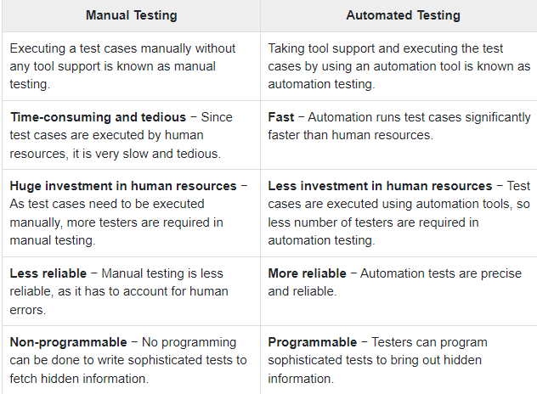

#### **Annotations for Junit testing**

The Junit 4.x framework is annotation based, so let's see the annotations that can be used while writing the test cases.

**@Test** annotation specifies that method is the test method.

**@Test(timeout=1000)** annotation specifies that method will be failed if it takes longer than 1000 milliseconds (1 second).

**@BeforeClass** annotation specifies that method will be invoked only once, before starting all the tests.

**@Before** annotation specifies that method will be invoked before each test.

**@After** annotation specifies that method will be invoked after each test.

**@AfterClass** annotation specifies that method will be invoked only once, after finishing all the tests.

## **Assert class**

The org.junit.Assert class provides methods to assert the program logic.

#### Methods of Assert class

The common methods of Assert class are as follows:

1. **void assertEquals(boolean expected,boolean actual)**: checks that two primitives/objects are equal. It is overloaded.
2. **void assertTrue(boolean condition)**: checks that a condition is true.
3. **void assertFalse(boolean condition)**: checks that a condition is false.
4. **void assertNull(Object obj)**: checks that object is null.
5. **void assertNotNull(Object obj)**: checks that object is not null.

#### **Required jar files**

You need to load **junit4.jar** and **hamcrest-core.jar** files.

## **Simple JUnit example in eclipse IDE**

Let's see the directory structure of this example.

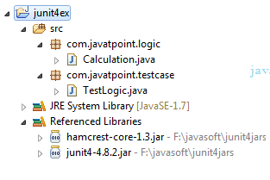

#### **Write the program logic**

Let's write the logic to find the maximum number for an array.

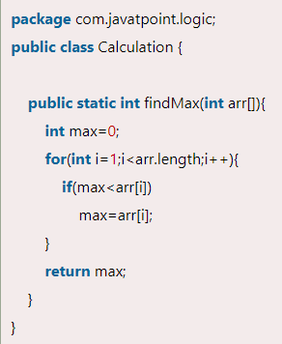

#### **Write the test case**

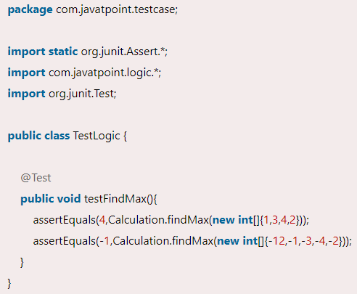

To run this example, **right click on TestLogic class -> Run As -> 1Junit Test**.

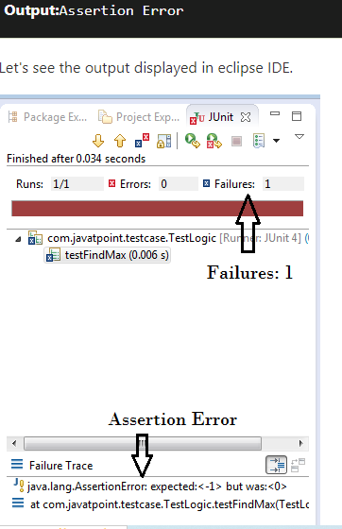

As you can see, when we pass the negative values, it throws AssertionError because second time findMax() method returns 0 instead of -1. It means our program logic is incorrect.

#### **Correct program logic**

As you can see, program logic to find the maximum number for the given array is not correct because it doesn't return -1 in case of negative values. The correct program logic is given below:

